TEAM ID: PNT2022TMID08163

PROJECT NAME: DemandEst - AI powered Food DemandForecaster

Team Leader

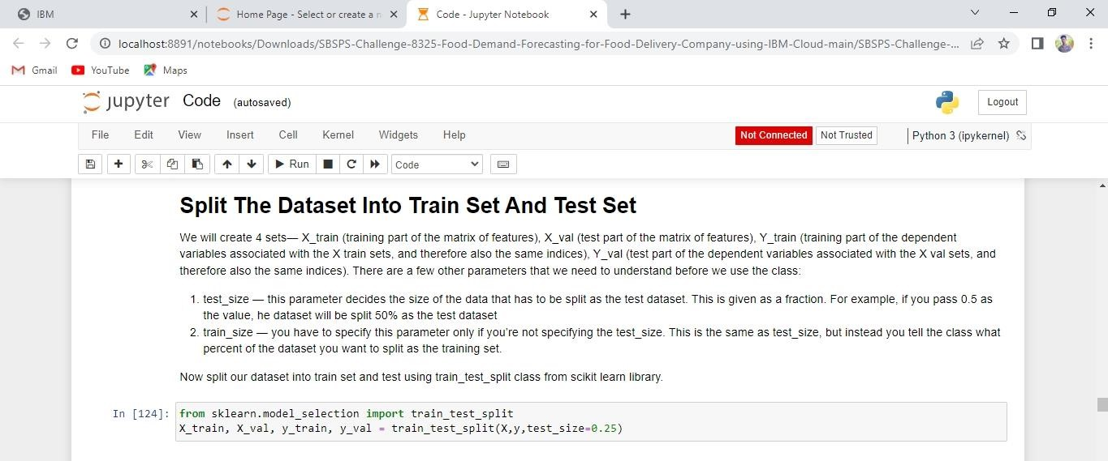

Team Member 1



Team Member 2`



Team Member 3

